Email Signature for Faculty
There are three different types of email signature formatting for faculty, and these are outlined on individual pages within this document. Please use the signature most appropriate.
Note: If you are using a different address, the last page of this document provides the other address content blocks to copy and paste from.
Continue reading the next pages for signature block examples and instructions…

Faculty Example #1

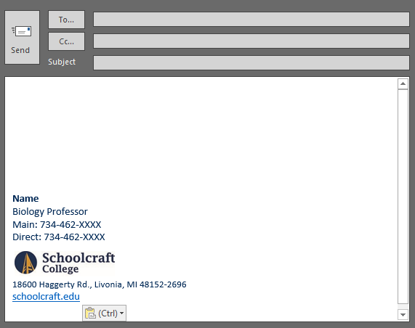  Above: Screencap of the email signature within an Outlook message window. | *PLEASE NOTE:  There is a hyperlink to the Schoolcraft College website when you click on the SC logo in your email signature.

Copy/Paste Block:
Instructions: Copy and paste the literal e-mail signature block content below into your signature email settings. You may find instructions on how to access and change your email settings online at: https://www.schoolcraft.edu/branding/email-signature
Name
Biology Professor
Main: 734-462-XXXX
Direct: 734-462-XXXX

18600 Haggerty Rd., Livonia, MI 48152-2696
schoolcraft.edu
Are you using another address?
Continue to the last page of this document for these content blocks…

Faculty Example #2

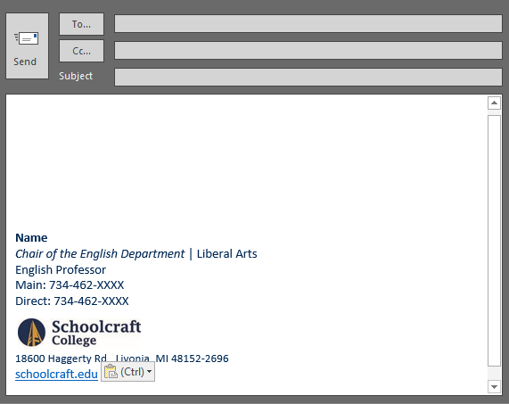  Above: Screencap of the email signature within an Outlook message window. | *PLEASE NOTE:  There is a hyperlink to the Schoolcraft College website when you click on the SC logo in your email signature.

Copy/Paste Block:
Instructions: Copy and paste the literal e-mail signature block content below into your signature email settings. You may find instructions on how to access and change your email settings online at: https://www.schoolcraft.edu/branding/email-signature
Name
Chair of the English Department | Liberal Arts
English Professor
Main: 734-462-XXXX
Direct: 734-462-XXXX

18600 Haggerty Rd., Livonia, MI 48152-2696
schoolcraft.edu
Are you using another address?
Continue to the last page of this document for these content blocks…

Faculty Example #3

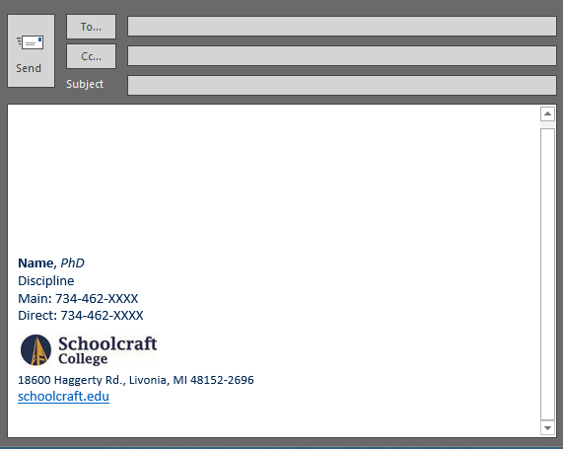  Above: Screencap of the email signature within an Outlook message window. | *PLEASE NOTE:  There is a hyperlink to the Schoolcraft College website when you click on the SC logo in your email signature.

Copy/Paste Block:
Instructions: Copy and paste the literal e-mail signature block content below into your signature email settings. You may find instructions on how to access and change your email settings online at: https://www.schoolcraft.edu/branding/email-signature
Name, PhD
Discipline
Main: 734-462-XXXX
Direct: 734-462-XXXX

18600 Haggerty Rd., Livonia, MI 48152-2696
schoolcraft.edu
Are you using another address?
Continue to the last page of this document for these content blocks…

Using the Radcliff Center Address:
Instructions: Copy and paste the Radcliff Address in place of the Livonia address if applicable.
1751 Radcliff St., Garden City, MI 48135
schoolcraft.edu

Using the Public Safety Training Complex Address:
Instructions: Copy and paste the PTSC address in place of the Livonia address if applicable.
31777 Industrial Road, Livonia, MI 48150
schoolcraft.edu

