Email Signature – Staff Example

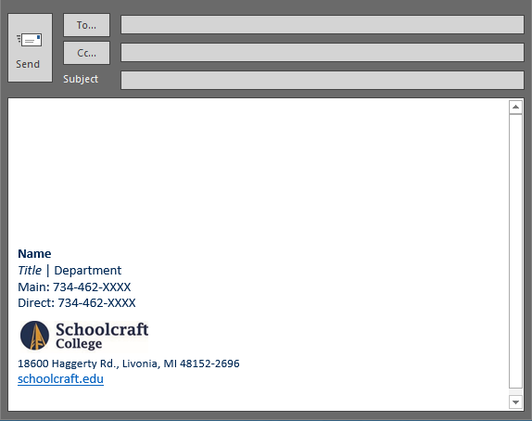  Above: Screencap of the email signature within an Outlook message window. | *PLEASE NOTE:  There is a hyperlink to the Schoolcraft College website when you click on the SC logo in your email signature.

Copy/Paste Block:
Instructions: Copy and paste the literal e-mail signature block content below into your signature email settings. You may find instructions on how to access and change your email settings online at: https://www.schoolcraft.edu/branding/email-signature
Name
Title | Department
Main: 734-462-XXXX
Direct: 734-462-XXXX

18600 Haggerty Rd., Livonia, MI 48152-2696
schoolcraft.edu

Are you using another address?
Continue to the next page for these content blocks…

Using the Radcliff Center Address:
Instructions: Copy and paste the Radcliff Address in place of the Livonia address if applicable.
1751 Radcliff St., Garden City, MI 48135
schoolcraft.edu

Using the Public Safety Training Complex Address:
Instructions: Copy and paste the PTSC address in place of the Livonia address if applicable.
31777 Industrial Road, Livonia, MI 48150
schoolcraft.edu

