How to Change an Email Signature in Microsoft Outlook
Instructions: Follow the steps below in order to update or add a new email signature.

- Within Microsoft Outlook, click File.
- Click Options.
- Select Mail.
- Click the Signatures button within the settings.
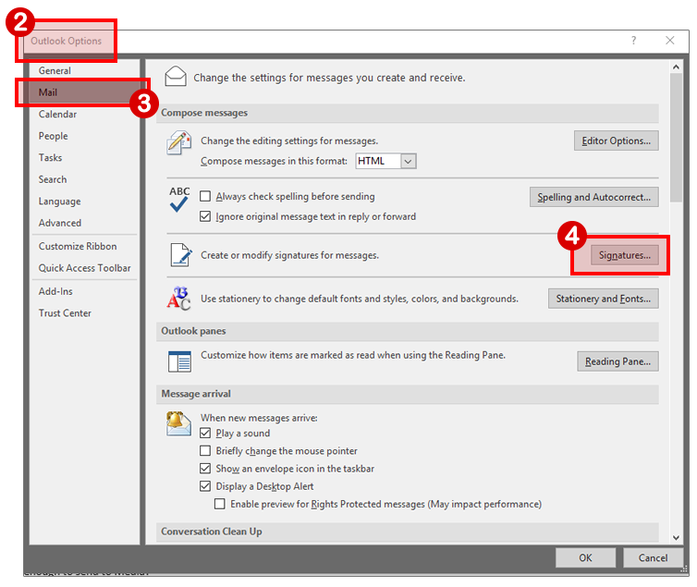
Continue reading…

- Within the Signatures and Stationery dialog box, select the New button.
- Copy and paste the appropriate signature content directly from the Word document download provided on this web page: https://www.schoolcraft.edu/branding/email-signature
Note: You will not visibly see the logo image in the footer. It will look like a blank block of whitespace. This logo image will save though and should visibly be seen within your email messages upon use.
